Milestone 2: Text Extraction, Semantic Structuring, and Analytical Review Generation

1. Objective
The objective of this milestone is to transform downloaded research paper PDFs into structured, machine-readable text, perform semantic sectioning using a Large Language Model, and generate higher-level analytical insights such as key findings, cross-paper comparisons, and an analytical draft.2. Environment Setup
The existing Python virtual environment from Milestone 1 was reused to maintain consistency across the project. Additional libraries were installed to support PDF parsing, semantic processing, and graph-based pipeline orchestration.
Key Libraries Used:
- PyMuPDF (fitz) – PDF text extraction
- langchain / langchain-google-genai – LLM integration with Gemini
- langgraph – Graph-based pipeline orchestration

3. Text Extraction Phase
In this phase, downloaded research paper PDFs are processed to extract raw textual content. PyMuPDF is used to parse each PDF page-by-page and extract text while handling variations in layout and formatting.
This phase converts binary PDF documents into raw textual data, forming the base input for subsequent processing steps.
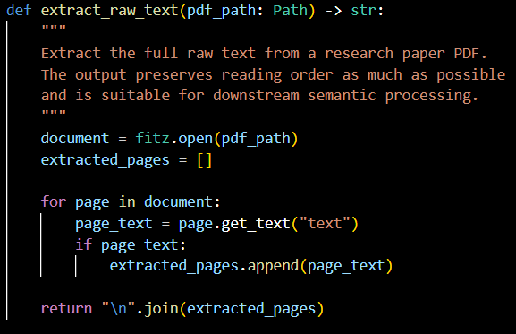

4. Text Normalization Phase
The extracted raw text often contains formatting noise such as excessive whitespace, broken lines, and page artifacts. A normalization module is applied to clean and standardize the extracted text.
Normalization ensures that the text is coherent and suitable for semantic understanding by language models, improving the accuracy of downstream sectioning and analysis.
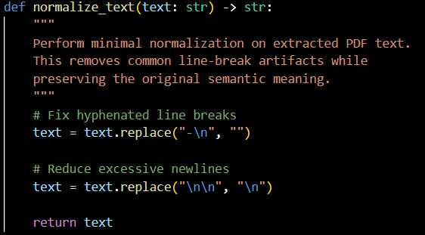

5. Semantic Sectioning Phase
The normalized text is semantically divided into logical research paper sections such as Abstract, Introduction, Methodology, Results, and Conclusion. This is achieved using a Gemini-based Large Language Model rather than relying on rigid rule-based heuristics.
Semantic sectioning ensures robustness across diverse paper formats and writing styles, even when explicit section headers are missing or inconsistent. The output is a structured JSON representation of each paper.
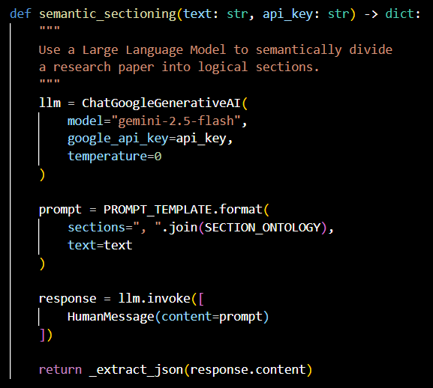

6. LangGraph Pipeline Refactoring
To ensure modularity and scalability, the extraction, normalization, and sectioning steps were refactored into a LangGraph-based pipeline.
Pipeline Design:
- Nodes represent single-responsibility tasks (extraction, normalization, sectioning)
- State maintains shared data across nodes during execution
- Graph definition specifies execution order without performing execution
- Runner module executes the graph for each research paper
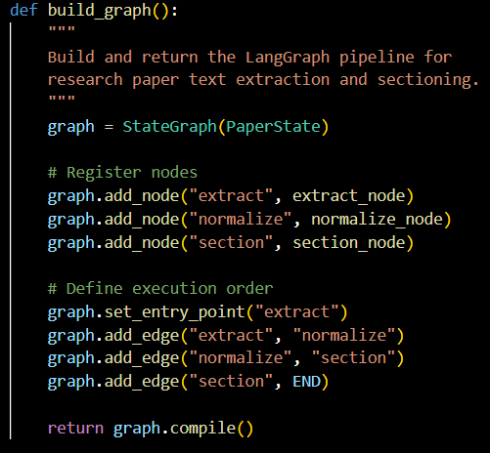

7. Validation Phase
Before performing analytical reasoning, the extracted section data is validated to ensure correctness and completeness. Papers missing essential sections or containing empty content are excluded from further analysis.
This validation step prevents incomplete or malformed data from affecting downstream analytical tasks.

8. Key Findings Extraction Phase
For each valid research paper, the system extracts key findings and core contributions using semantic reasoning via a Large Language Model. The model is instructed to rely strictly on the provided content and return findings in a structured format.
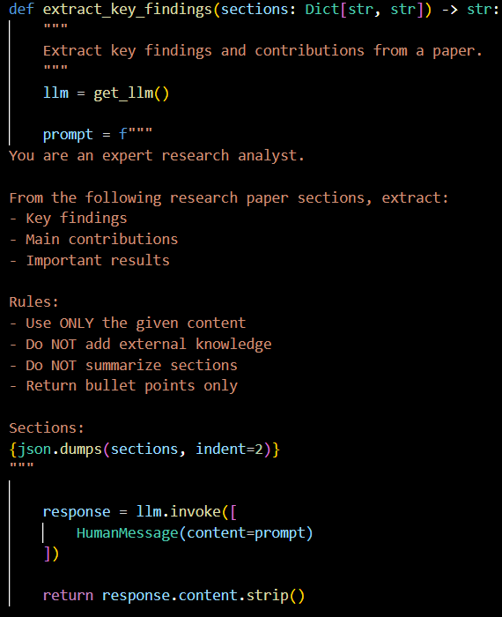

9. Cross-Paper Comparison Phase

For each valid research paper, the system extracts key findings and core contributions using semantic reasoning via a Large Language Model. The model is instructed to rely strictly on the provided content and return findings in a structured format.

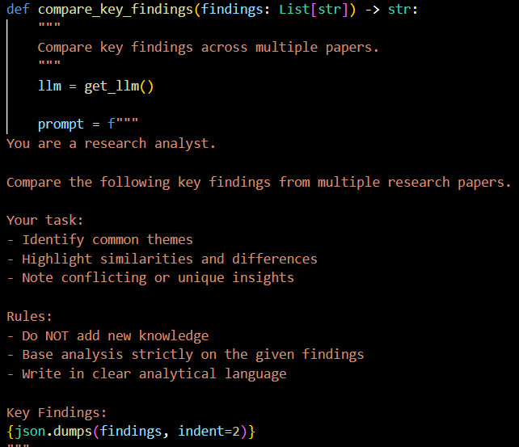

10. Analytical Draft Generation Phase
Based on the validated sections, extracted key findings, and cross-paper comparison, the system generates a comprehensive analytical draft. This draft resembles a human-written research review and synthesizes insights across all relevant papers for the selected topic.
The draft generation step represents the culmination of the automated review pipeline.
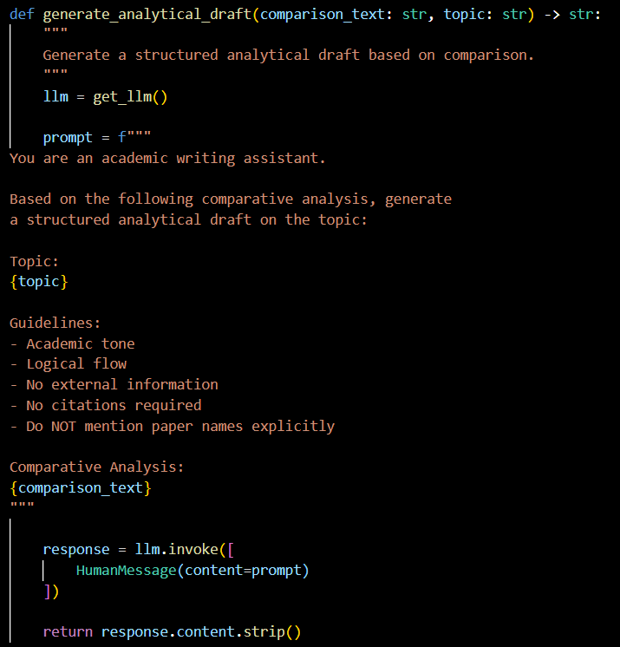

11. Output
Milestone 2 establishes a reliable and automated pipeline for research paper retrieval and dataset preparation. The modular design ensures scalability and provides a strong foundation for further development in the next milestones.

12. Conclusion
Milestone 2 extends the project from data collection to intelligent understanding and synthesis of research content. By integrating semantic sectioning, graph-based processing, and analytical reasoning, the system moves closer to a fully automated research paper review and summarization platform

